**CSA-0805-PYTHON PROGRAM**

**LEVEL- 2**

**NAME:-A.Thrilokesh DATE:-16/10/25**

**REG NO:-192425098 SUBJECT:-Python**

1 .To count all the prime numbers and composite numbers

Sample input: 4,54,29,71,59,98,23

Output: composite numbers=3

Prime numbers = 5

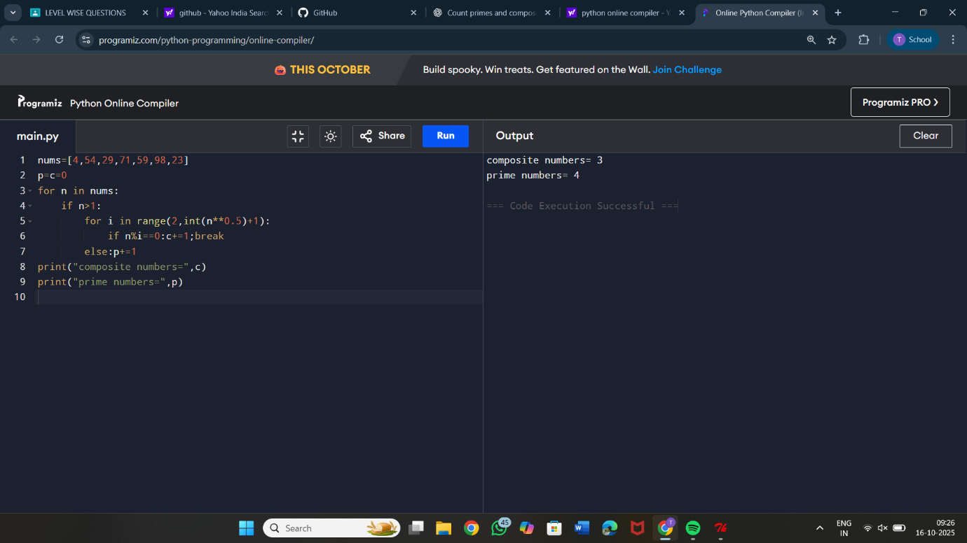

2. Sum of daigonal matrix

Sample input: [1 2 3 4 5 6 7 8 9]

Output: diagonal elements are 1,5,9

Sum of diagonal elements=15

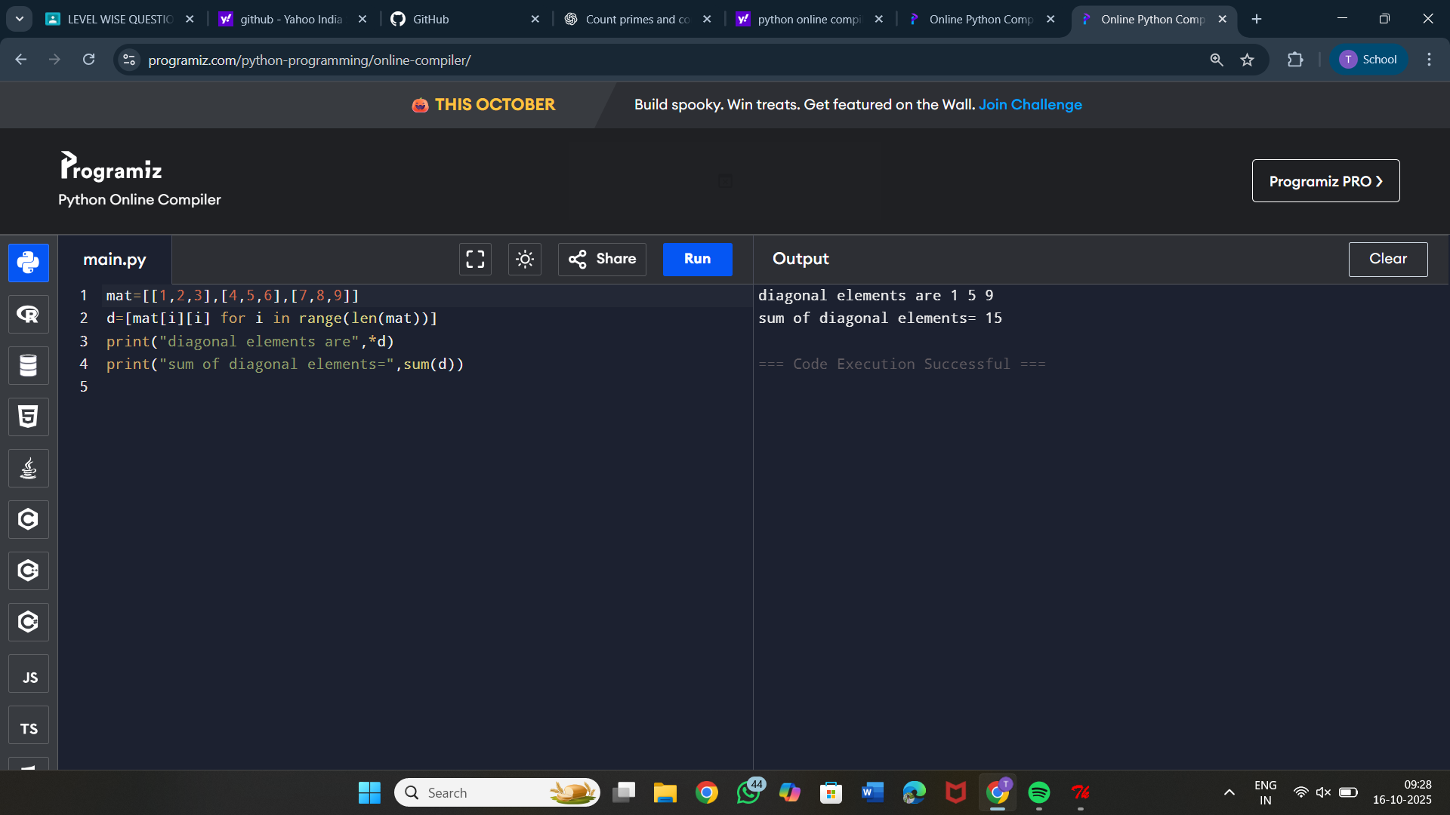

3. Perfect number or not

Sample Input: 6

Output: it is a perfect number

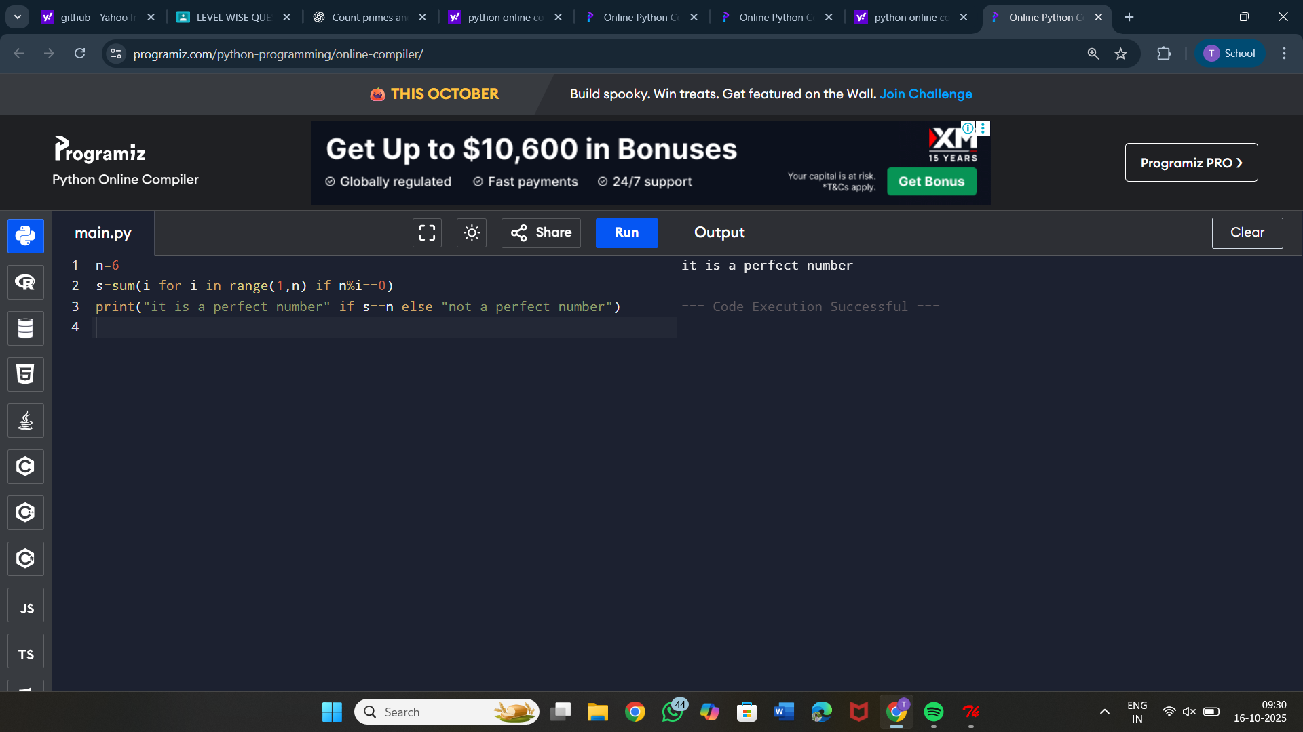

4. Write a program in Python to read the elements of a one-dimensional array,

compare the elements and find which are the largest two elements in a given

array.

Sample Input:

1 2 3 4 5 6 7

Output:

Largest two elements : 6 &amp; 7

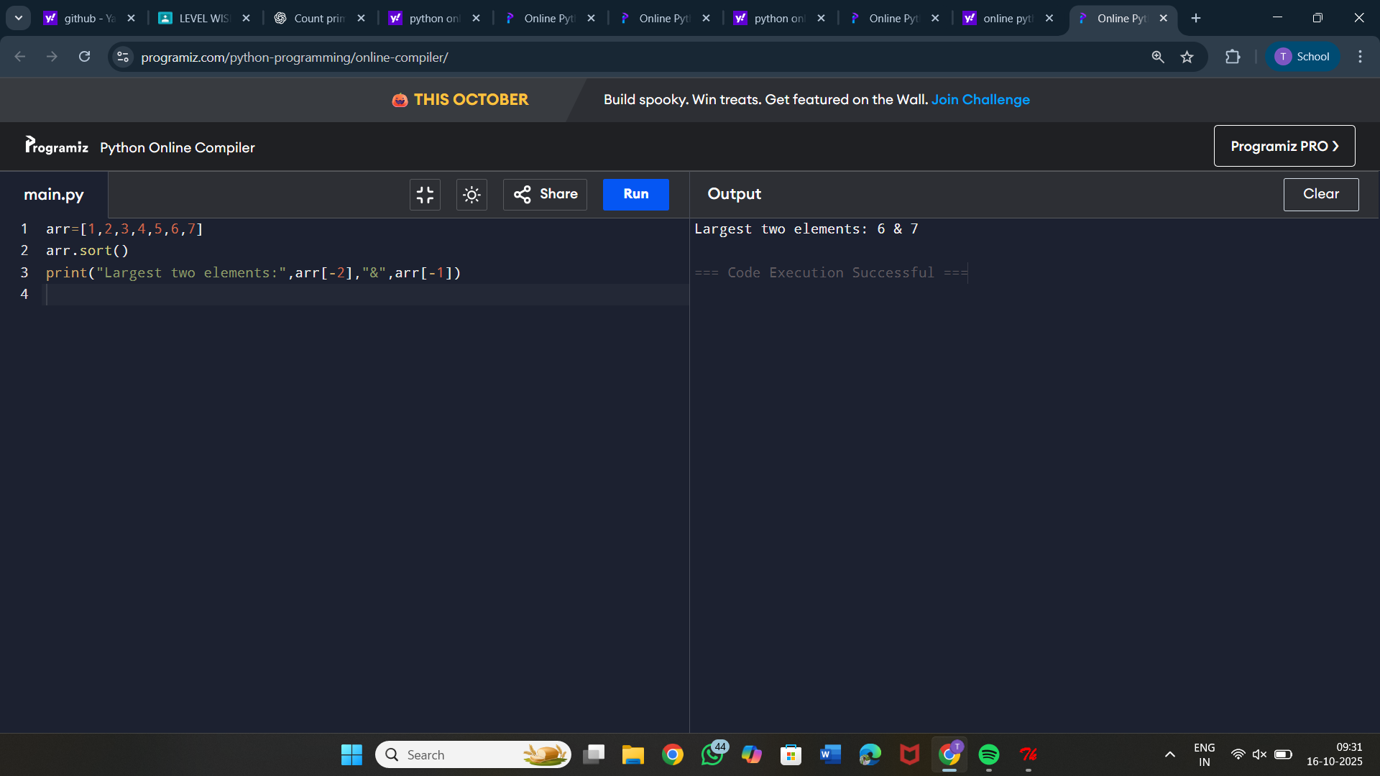

5. Find the Mth maximum number and Nth minimum number in an array and

find the sum and difference of it.

Sample Input:

Array of elements = {14, 16, 87, 36, 25, 89, 34}

M = 1

N = 3

Output:

1st Maximum Number = 89

3rd Minimum Number = 25

Sum = 114

Difference = 64

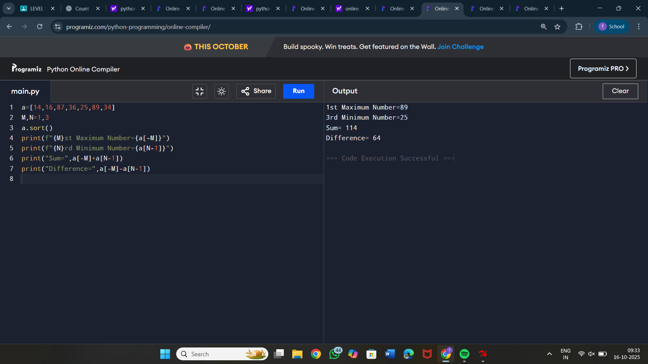

6. Find GCD and LCM in Python

Sample Input &amp; Output:

LCM of 15 and 20 is 60

The gcd of 60 and 48 is : 12

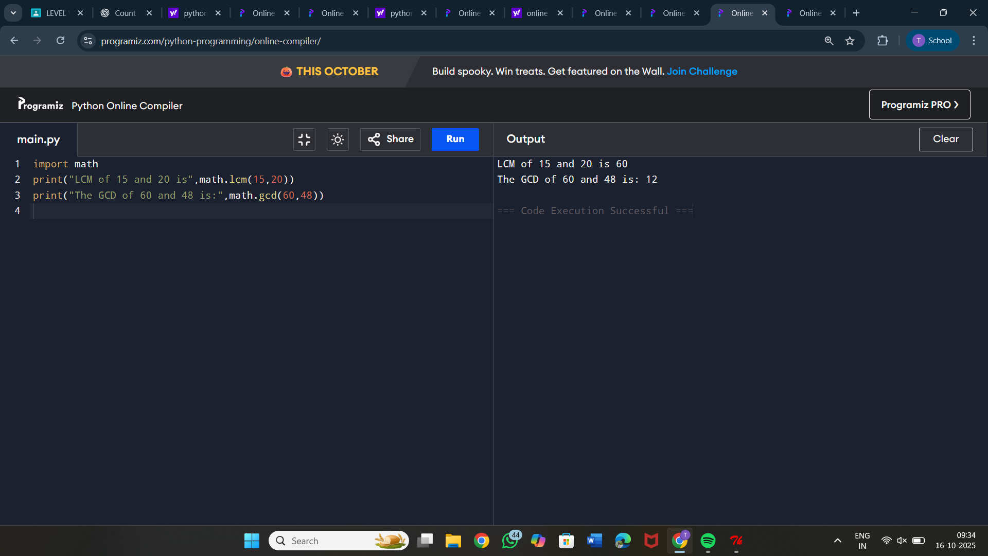

7. Write a Python program to display customer name mobile number and cost of

the purchase.calculate the discount and find the total amount to be paid.

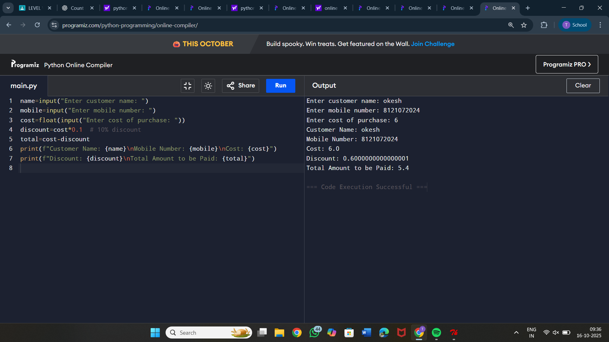

8. Write a Python program to find largest 2nd maximum in array

Sample Input:

a={1,6,4,2}

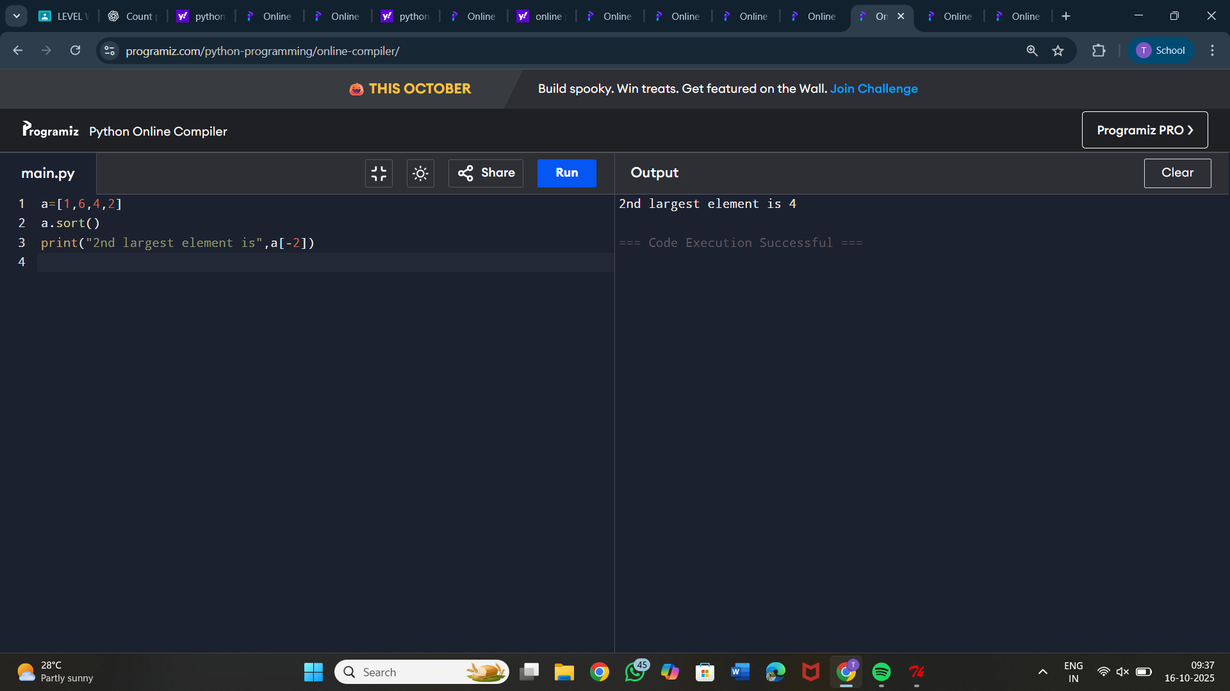Output:4

9. You are give with an array which contains integer element. Sort the elements

in non-increasing order and print the middle element of the array.

Sample Input:

arr = {90,-90,80,66,78,10}

Output:

{-90,10,66,78,80,90}

Mid-element:66

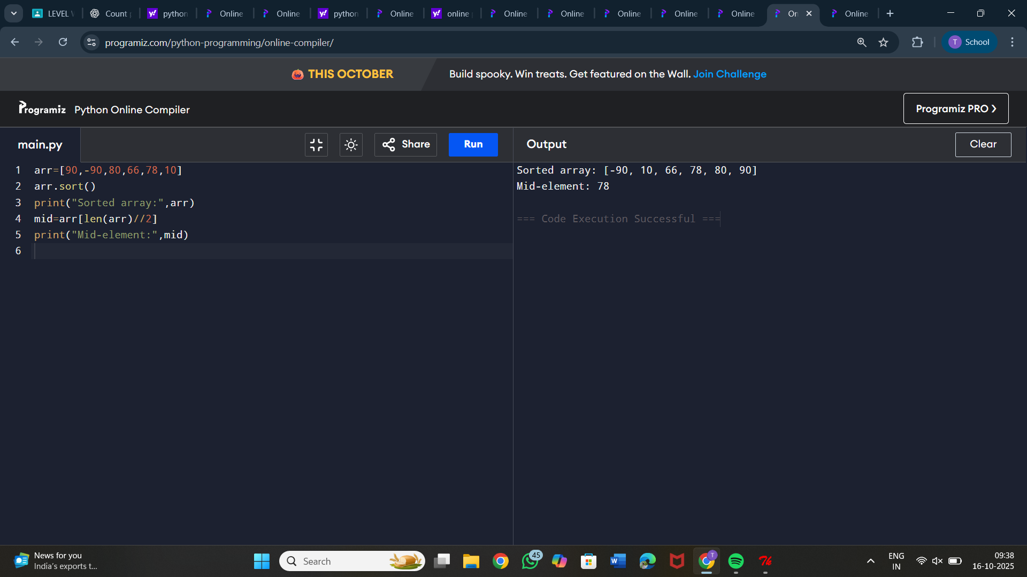

10. Write a python program to print multiplication of 3 matrices.

First matrix elements:

1 1 1

2 2 2

3 3 3

Second matrix elements

1 1 1

2 2 2

3 3 3

Third matrix elements

1 1 1

2 2 2

3 3 3

multiplication of the matrix:

36 36 36

72 72 72

108 108 108

